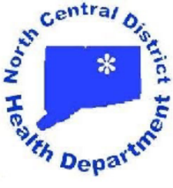
North Central District Health Department
Enfield—31 North Main Street, Enfield, CT 06082 * (860) 745-0383 Fax (860) 745-3188
Vernon—375 Hartford Turnpike, Room 120, Vernon, CT 06066 * (860) 872-1501 Fax (860) 872 1531
Windham—Town Hall, 979 Main Street, Willimantic, CT 06226 * (860) 465-3033 Fax (860) 465-3034
Stafford—Town Hall, 1 Main Street, Stafford Springs, CT 06076 * (860) 684-5609 Fax (860) 684-1768

Patrice A. Sulik, MPH, R.S.
Director of Health

PRESS RELEASE

NORTH CENTRAL DISTRICT HEALTH DEPARTMENT OFFERS PUBLIC FLU CLINICS, NO APPOINTMENT NECESSARY

The North Central District Health Department is pleased to offer public flu clinics at our Main Office in Enfield at 31 North Main Street. The clinic dates are Tuesday, November 13th from 3:00-6:00 PM and Wednesday, November 14th from 9:00 AM to noon. No appointments are necessary. For those age 4 and older, we have Flucelvax Quadrivalent vaccine by Seqirus. For individuals 65 and older who are interested in the high potency vaccine, we have a limited supply of Fluzone High-Dose vaccine by Sanofi Pasteur. If you are interested in the high potency vaccine, please call the Health District at 860-745-0383 to reserve your dose. The Health District can accept the following insurances: Medicare Part B, Aetna, Cigna, and Connecticare. The cash price is $25.00 for the quadrivalent and $45.00 for the high-dose. Cash and checks will be accepted. If you have any questions, please contact the Public Health Nurse at 860-745-0383.

